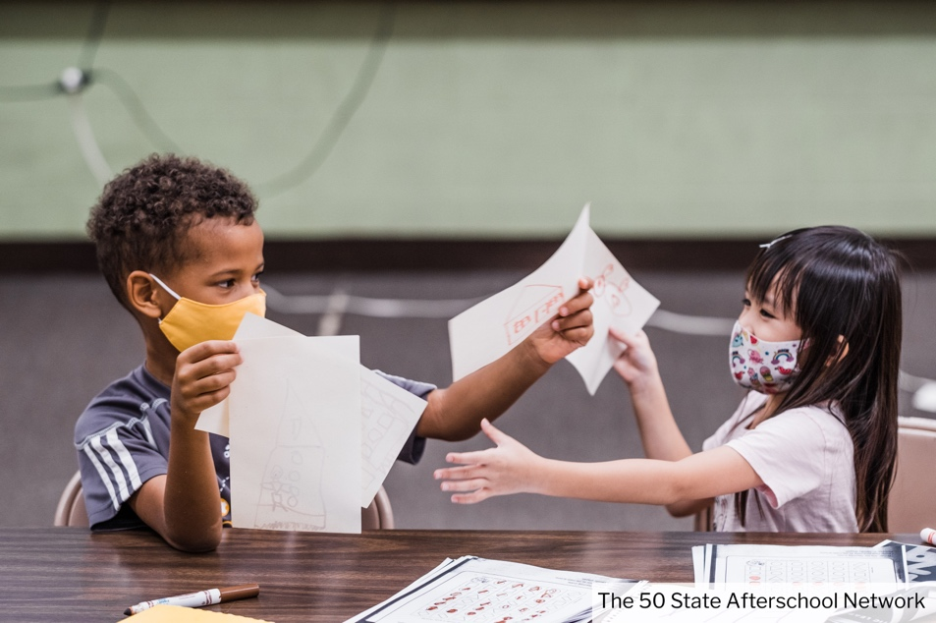

Supporting Afterschool &

Summer Learning in [STATE]

with ESSER II Funding

**Why Are Afterschool and Summer Learning Programs  
So Important?**

* **Proven to accelerate learning gains and address learning loss.** Programs engage students in enriching, hands-on projects that provide more time for deeper learning. And staff ensure students who are struggling get the extra help they need.
* **Intentional focus on social-emotional learning and kids’ mental health.** Programs connect young people with caring mentors who are trained to help youth build healthy relationships, navigate challenges, make good decisions, and heal from trauma.
* **Keep kids safe and engaged.** Programs provide a safe place for youth to learn and gain critical social and life skills, including leadership, critical thinking, and teamwork. They care for young people both during and beyond the school day, allowing parents to return to work or take time to seek employment.

**Access to Out-of-School Time Programs Is Not Always Equitable**

Cost and access prevent many students from low-income families and students of color from participating. These gaps are likely to grow, with many more families struggling from job losses and fallout from the pandemic. Nationwide, nearly 25 million students are missing out on afterschool learning opportunities.

**Learning Happens  
Outside of School Too!**

Afterschool and summer learning programs are essential for students’ recovery and helping kids reach their full potential. For K-12 students, more than 80% of their time is spent learning outside of school.

Time spent in formal learning environments including school

Time spent in informal learning environments or settings outside of school

**How Can the ESSER II Fund Help Ensure Access to Expanded Learning Opportunities in [STATE]?**

**Ideas for Implementation**

* Create or increase access to existing afterschool, summer, or intercession learning opportunities.
* Partner with local community organizations that provide afterschool and summer learning programs to offer youth more opportunities to engage and more access to caring adults.
* Provide on-going, sustainable opportunities for small group programming, including enrichment, tutoring, life-skills development, college and career exposure, and more.
* Increase family engagement and empowerment opportunities.

**Embrace Nontraditional Learning!**

Afterschool and summer programs complement classroom learning and provide real-world experiences for students of all ages. Students who participate benefit, students from families with low-income demonstrate the greatest gains.

* Hands-on project-based learning
* STEM, arts and music
* Planning and preparing for college
* Career exploration, internships, mentoring
* Service learning and community projects
* Logo

  Description automatically generatedYouth led learning and social activities
* Physical activity

**Resources**

STATE AFTERSCHOOL STANDARDS (add URL): Curious about how to measure quality and impact? Utilize these standards to create the foundation for your program!

STATE AFTERSCHOOL NETWORK (add URL): Lean on our state's leading afterschool intermediary for an abundance of resources on program design, staff development, and afterschool and summer programming academic outcomes.

[Afterschool Alliance](http://www.afterschoolalliance.org/AA3PM/): This national organization is a great place to stay up-to-date on program trends and policy development. You can also find state and national data about the demand for afterschool and summer programs.

[National Summer Learning Association](https://www.summerlearning.org/): Looking for resources specific to summer learning? NSLA has one goal--investing in summer learning to help close the achievement gap. Their website is a hub for resources targeted at summer program staff, parents and caregivers, and educators.

**Questions? Contact us!**

Name, Title

Phone

Email

Network physical address and/or URL